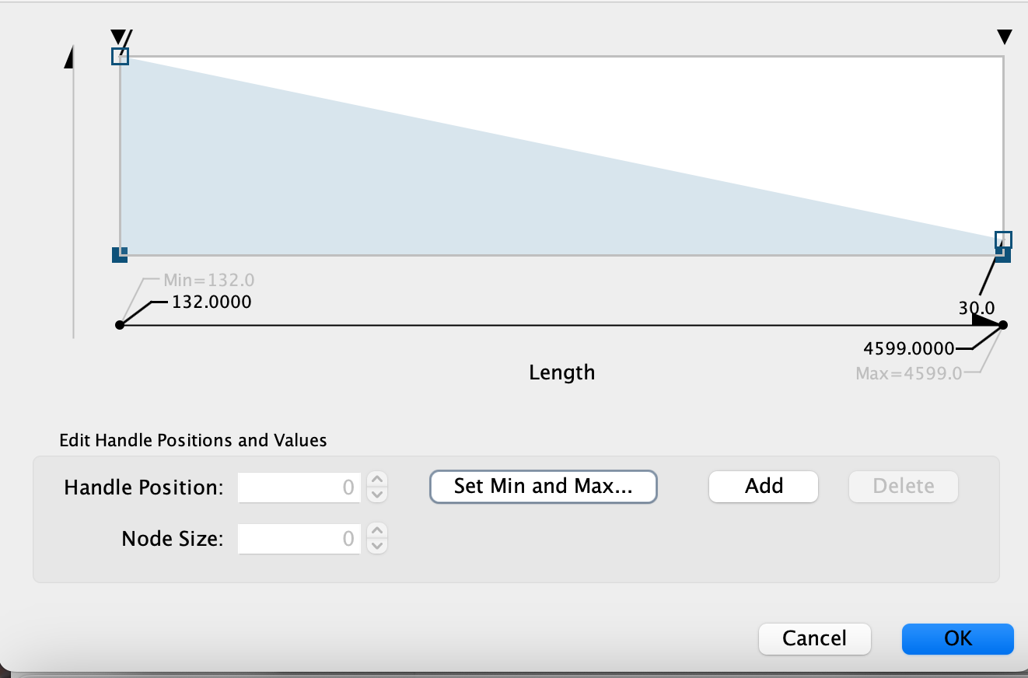

Node size was mapped to protein length using a continuous scale with node sizes ranging from 10 to 30. Smaller nodes represent longer proteins. Longer proteins are shown as smaller sized nodes. The protein length ranges from 132 (minimum) to 4599 (maximum) amino acids. 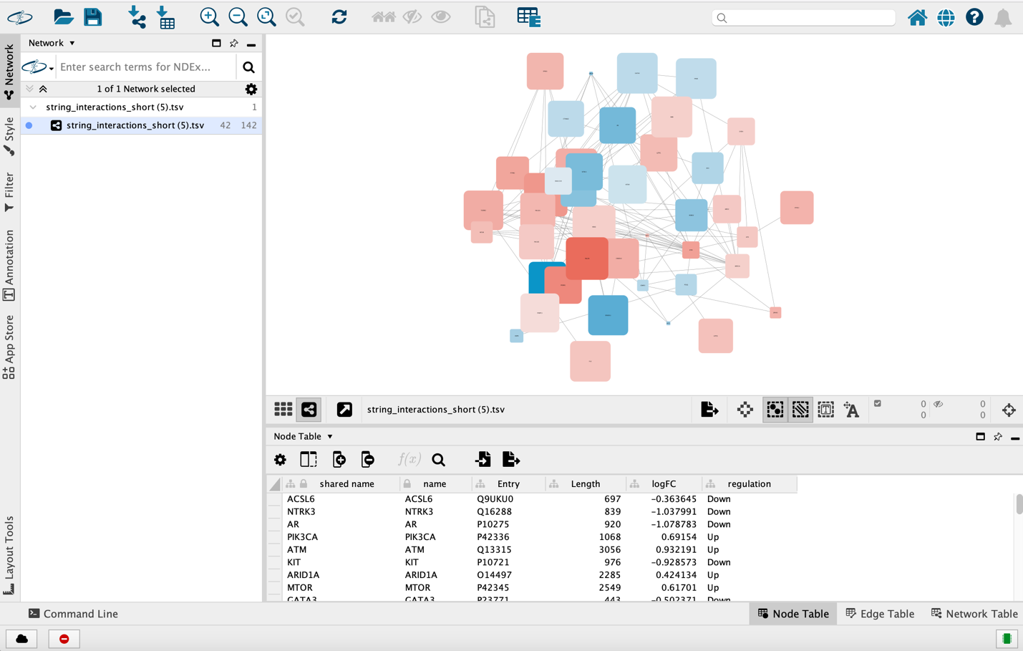
Protein-protein interaction network with expression and protein length annotations

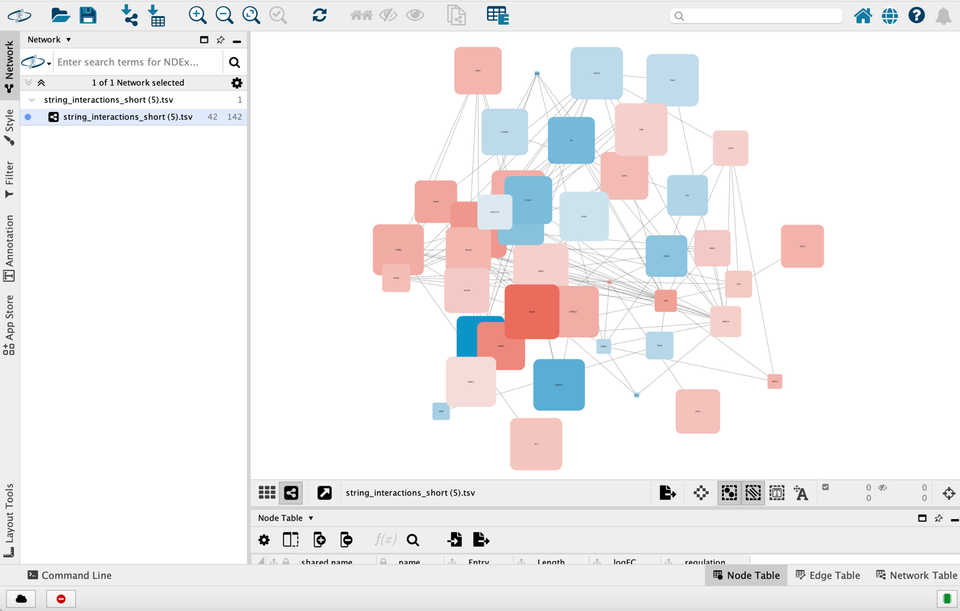
Fully integrated protein-protein interaction (PPI) network visualization in Cytoscape.

